# Karyotype Report

Customer sample ID: S17

Internal sample ID: LU42DIVULUD100056

Date of receipt: 2017-02-24

Gender

Stated: Male

Chr. X derived: Male

Genotype identity with: S18-24.02.2017 / LUDIVULU00057

## Karyotyping

Technology used: Illumina BeadArray

Product: HumanOmniExpressExome-8 BeadChip v1.3

Manifest file: HumanOmniExpressExome-8v1-3_A.bpm

Cluster file: HumanOmniExpressExome-8v1-3_A.egt

Chip barcode and segment: 200729690126 R04C01

Batch ID and 96 well position: WG1001271-MSA1 D04

Call rate: 0,999

Typing

Scanner: Illumina iScan, S/N: N234

Site of processing: Life&Brain GENOMICS, Bonn, Germany

Manufacturer: Illumina, Inc., San Diego, United States of America

Date of scan: 2017-03-22-2218

Genotype Analysis

Genome Studio: GenomeStudio V2.0.2

Genotyping module: Ver. 2.0.2

Copy Number Analysis

Algorithm applied: CNV-Partition

Version: 3.2

Software producer: Illumina, Inc., San Diego, United States of America

### Noteworthy findings

No larger chromosomal aberrations to be reported.

### Analyst

Stefan Herms

Stefan.Herms@unibas.ch

Tel.: +41 61 328 50 19

### Control Dashboard

|  |  |  |  |  |  |
| --- | --- | --- | --- | --- | --- |
| **Sample_ID / Sentrix_Label** | **Category** | **Control (BeadType)** | **Section 1 X** | **Section 1 Y** | **State** |
| LUDIVULU00056 / 200729690126_R04C01 | Staining | DNP (High) (27630314) | 32562 | 261 | OK/OK |
| LUDIVULU00056 / 200729690126_R04C01 | Staining | DNP (Bgnd) (29619375) | 410 | 173 | OK/OK |
| LUDIVULU00056 / 200729690126_R04C01 | Staining | Biotin (High) (41666334) | 454 | 14892 | OK/OK |
| LUDIVULU00056 / 200729690126_R04C01 | Staining | Biotin (Bgnd) (34648333) | 380 | 361 | OK/OK |
| LUDIVULU00056 / 200729690126_R04C01 | Extension | Extension (A) (17616306) | 38708 | 293 | OK/OK |
| LUDIVULU00056 / 200729690126_R04C01 | Extension | Extension (T) (14607337) | 38655 | 212 | OK/OK |
| LUDIVULU00056 / 200729690126_R04C01 | Extension | Extension (C) (12613307) | 1322 | 22012 | OK/OK |
| LUDIVULU00056 / 200729690126_R04C01 | Extension | Extension (G) (11603365) | 1915 | 21637 | OK/OK |
| LUDIVULU00056 / 200729690126_R04C01 | Target Removal | Target Removal (31623323) | 745 | 168 | OK/OK |
| LUDIVULU00056 / 200729690126_R04C01 | Hybridization | Hyb (High) (19612319) | 1667 | 21089 | OK/OK |
| LUDIVULU00056 / 200729690126_R04C01 | Hybridization | Hyb (Medium) (20636378) | 474 | 13700 | OK/OK |
| LUDIVULU00056 / 200729690126_R04C01 | Hybridization | Hyb (Low) (23617335) | 1696 | 4136 | OK/OK |
| LUDIVULU00056 / 200729690126_R04C01 | Stringency | String (PM) (32629312) | 25008 | 393 | OK/OK |
| LUDIVULU00056 / 200729690126_R04C01 | Stringency | String (MM) (33668307) | 4556 | 162 | OK/OK |
| LUDIVULU00056 / 200729690126_R04C01 | Non-Specific Binding | NSB (Bgnd) (26619332) | 326 | 110 | OK/OK |
| LUDIVULU00056 / 200729690126_R04C01 | Non-Specific Binding | NSB (Bgnd) (27624356) | 355 | 164 | OK/OK |
| LUDIVULU00056 / 200729690126_R04C01 | Non-Specific Binding | NSB (Bgnd) (25617343) | 362 | 218 | OK/OK |
| LUDIVULU00056 / 200729690126_R04C01 | Non-Specific Binding | NSB (Bgnd) (24616350) | 365 | 160 | OK/OK |
| LUDIVULU00056 / 200729690126_R04C01 | Non-Polymorphic | NP (A) (34633358) | 16245 | 295 | OK/OK |
| LUDIVULU00056 / 200729690126_R04C01 | Non-Polymorphic | NP (T) (16648324) | 15136 | 241 | OK/OK |
| LUDIVULU00056 / 200729690126_R04C01 | Non-Polymorphic | NP (C) (43641328) | 763 | 13170 | OK/OK |
| LUDIVULU00056 / 200729690126_R04C01 | Non-Polymorphic | NP (G) (13642359) | 700 | 12419 | OK/OK |
| LUDIVULU00056 / 200729690126_R04C01 | Restoration | Restore (28637363) | 309 | 293 | OK/OK |

All „Notable“ tagged probes are within specs. The karyogram can be evaluated.

## Karyogram

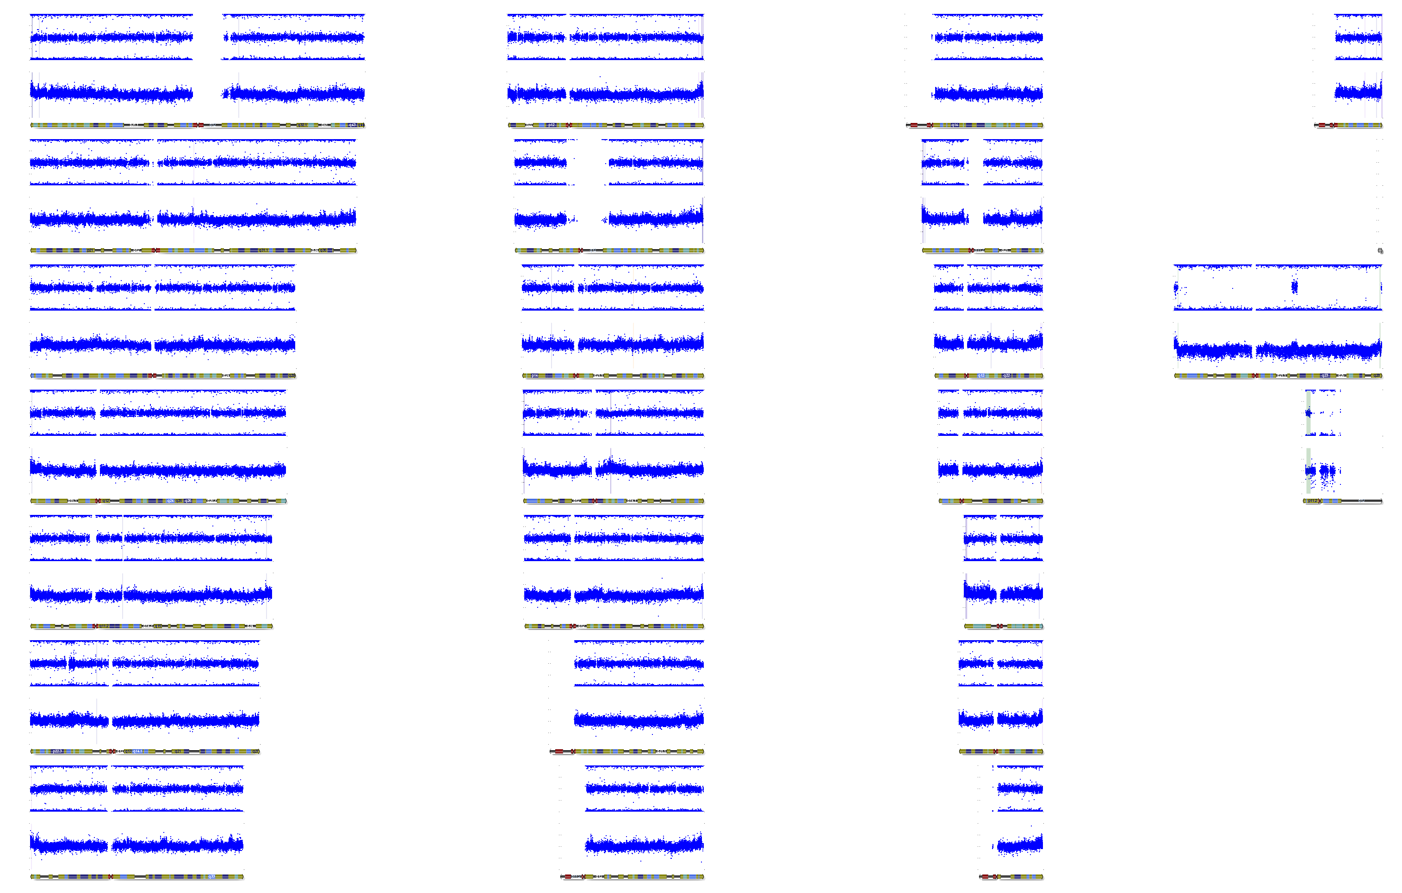

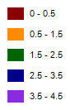

## Copy Number Analysis

Copy number events will be reported if larger than 350'000 base pairs.

Database of Genomic Variants comparison: Number stated represent population based copy number variants that span the reported event completely.

Copy number analysis

Algorithm applied: CNV-Partition

Version: 3.2

Software producer: Illumina, Inc., San Diego, United States of America

|  |  |  |  |  |  |  |  |  |
| --- | --- | --- | --- | --- | --- | --- | --- | --- |
| **Sample ID** | **Chr** | **Start** | **End** | **Type** | **Length** | **Marker count** | **CN Confidence** | **DGV Comparison** |
| LUDIVULU00056 | 24 | 2929037 | 6033626 | 2 | 3104589 | 160 | 44,4339 |  |