# Karyotype Report

Customer sample ID: CLN3_Q352X

Internal sample ID: LU73DIVULUD100080

Date of receipt: 09.09.2017

Gender

Stated: Female

Chr. X derived: Female

Genotype identity with: S19-2017-02-24 / LUDIVULU00058, S20-2017-02-24 / LUDIVULU00059, S21-2017-02-24 / LUDIVULU00060, S22-2017-02-24 / LUDIVULU00061, S23-2017-02-24 / LUDIVULU00062, A13777 2017-09-09 / LUDIVULU00081

## Karyotyping

Technology used: Illumina BeadArray

Product: HumanOmni2.5Exome-8 BeadChip v1.3

Manifest file: HumanOmni2-5Exome-8v1-3_A1.bpm

Cluster file: HumanOmni2-5Exome-8v1-3_A1.egt

Chip barcode and segment: 201340820084 R07C01

Batch ID and 96 well position: WG5830318-MSA6 G03

Call rate: 0,9961981

Typing

Scanner: Illumina iScan, S/N: N234

Site of processing: Life&Brain GENOMICS, Bonn, Germany

Manufacturer: Illumina, Inc., San Diego, United States of America

Date of scan: 2017-09-12-1554

Genotype Analysis

Genome Studio: GenomeStudio V2.0.2

Genotyping module: Ver. 2.0.2

Copy Number Analysis

Algorithm applied: CNV-Partition

Version: 3.2

Software producer: Illumina, Inc., San Diego, United States of America

### Noteworthy findings

No larger chromosomal aberrations to be reported. Noteworthy: Chr20: Duplication in q11.21.

### Analyst

Stefan Herms

Stefan.Herms@unibas.ch

Tel.: +41 61 328 50 19

### Control Dashboard

|  |  |  |  |  |  |
| --- | --- | --- | --- | --- | --- |
| **Sample_ID / Sentrix_Label** | **Category** | **Control (BeadType)** | **Section 1 X** | **Section 1 Y** | **State** |
| LUDIVULU00080 / 201340820084_R07C01 | Staining | DNP (High) (27630314) | 26687 | 76 | OK/OK |
| LUDIVULU00080 / 201340820084_R07C01 | Staining | DNP (Bgnd) (29619375) | 475 | 357 | OK/OK |
| LUDIVULU00080 / 201340820084_R07C01 | Staining | Biotin (High) (41666334) | 475 | 13762 | OK/OK |
| LUDIVULU00080 / 201340820084_R07C01 | Staining | Biotin (Bgnd) (34648333) | 402 | 102 | OK/OK |
| LUDIVULU00080 / 201340820084_R07C01 | Extension | Extension (A) (17616306) | 29212 | 500 | OK/OK |
| LUDIVULU00080 / 201340820084_R07C01 | Extension | Extension (T) (14607337) | 31414 | 383 | OK/OK |
| LUDIVULU00080 / 201340820084_R07C01 | Extension | Extension (C) (12613307) | 1430 | 17543 | OK/OK |
| LUDIVULU00080 / 201340820084_R07C01 | Extension | Extension (G) (11603365) | 1747 | 16523 | OK/OK |
| LUDIVULU00080 / 201340820084_R07C01 | Target Removal | Target Removal (31623323) | 1056 | 294 | OK/OK |
| LUDIVULU00080 / 201340820084_R07C01 | Hybridization | Hyb (High) (19612319) | 1967 | 16143 | OK/OK |
| LUDIVULU00080 / 201340820084_R07C01 | Hybridization | Hyb (Medium) (20636378) | 650 | 10159 | OK/OK |
| LUDIVULU00080 / 201340820084_R07C01 | Hybridization | Hyb (Low) (23617335) | 1801 | 3264 | OK/OK |
| LUDIVULU00080 / 201340820084_R07C01 | Stringency | String (PM) (32629312) | 20977 | 525 | OK/OK |
| LUDIVULU00080 / 201340820084_R07C01 | Stringency | String (MM) (33668307) | 7394 | 393 | Notable/OK |
| LUDIVULU00080 / 201340820084_R07C01 | Non-Specific Binding | NSB (Bgnd) (26619332) | 473 | 267 | OK/OK |
| LUDIVULU00080 / 201340820084_R07C01 | Non-Specific Binding | NSB (Bgnd) (27624356) | 554 | 196 | OK/OK |
| LUDIVULU00080 / 201340820084_R07C01 | Non-Specific Binding | NSB (Bgnd) (25617343) | 560 | 297 | OK/OK |
| LUDIVULU00080 / 201340820084_R07C01 | Non-Specific Binding | NSB (Bgnd) (24616350) | 552 | 252 | OK/OK |
| LUDIVULU00080 / 201340820084_R07C01 | Non-Polymorphic | NP (A) (34633358) | 10894 | 437 | OK/OK |
| LUDIVULU00080 / 201340820084_R07C01 | Non-Polymorphic | NP (T) (16648324) | 13104 | 347 | OK/OK |
| LUDIVULU00080 / 201340820084_R07C01 | Non-Polymorphic | NP (C) (43641328) | 775 | 9179 | OK/OK |
| LUDIVULU00080 / 201340820084_R07C01 | Non-Polymorphic | NP (G) (13642359) | 875 | 7610 | OK/OK |
| LUDIVULU00080 / 201340820084_R07C01 | Restoration | Restore (28637363) | 538 | 372 | OK/OK |

All „Notable“ tagged probes are within specs. The karyogram can be evaluated.

## Karyogram

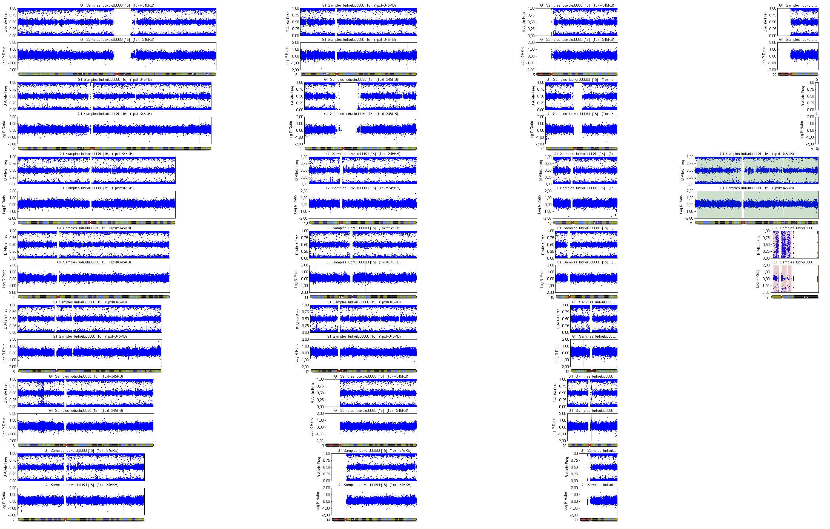

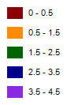

## Copy Number Analysis

Copy number events will be reported if larger than 350'000 base pairs, 1Mbp for loss of heterozygosity regions.

Database of Genomic Variants comparison: Number stated represent population based copy number variants that span the reported event completely.

Copy number analysis

Algorithm applied: CNV-Partition

Version: 3.2

Software producer: Illumina, Inc., San Diego, United States of America

|  |  |  |  |  |  |  |  |  |
| --- | --- | --- | --- | --- | --- | --- | --- | --- |
| **Sample ID** | **Chr** | **Start** | **End** | **Type** | **Length** | **Marker count** | **CN Confidence** | **DGV Comparison** |
| LUDIVULU00080 | 7 | 132635483 | 133191127 | 3 | 555644 | 320 | 1165,802 |  |
| LUDIVULU00080 | 20 | 29652992 | 30753220 | 3 | 1100228 | 761 | 487,2755 |  |