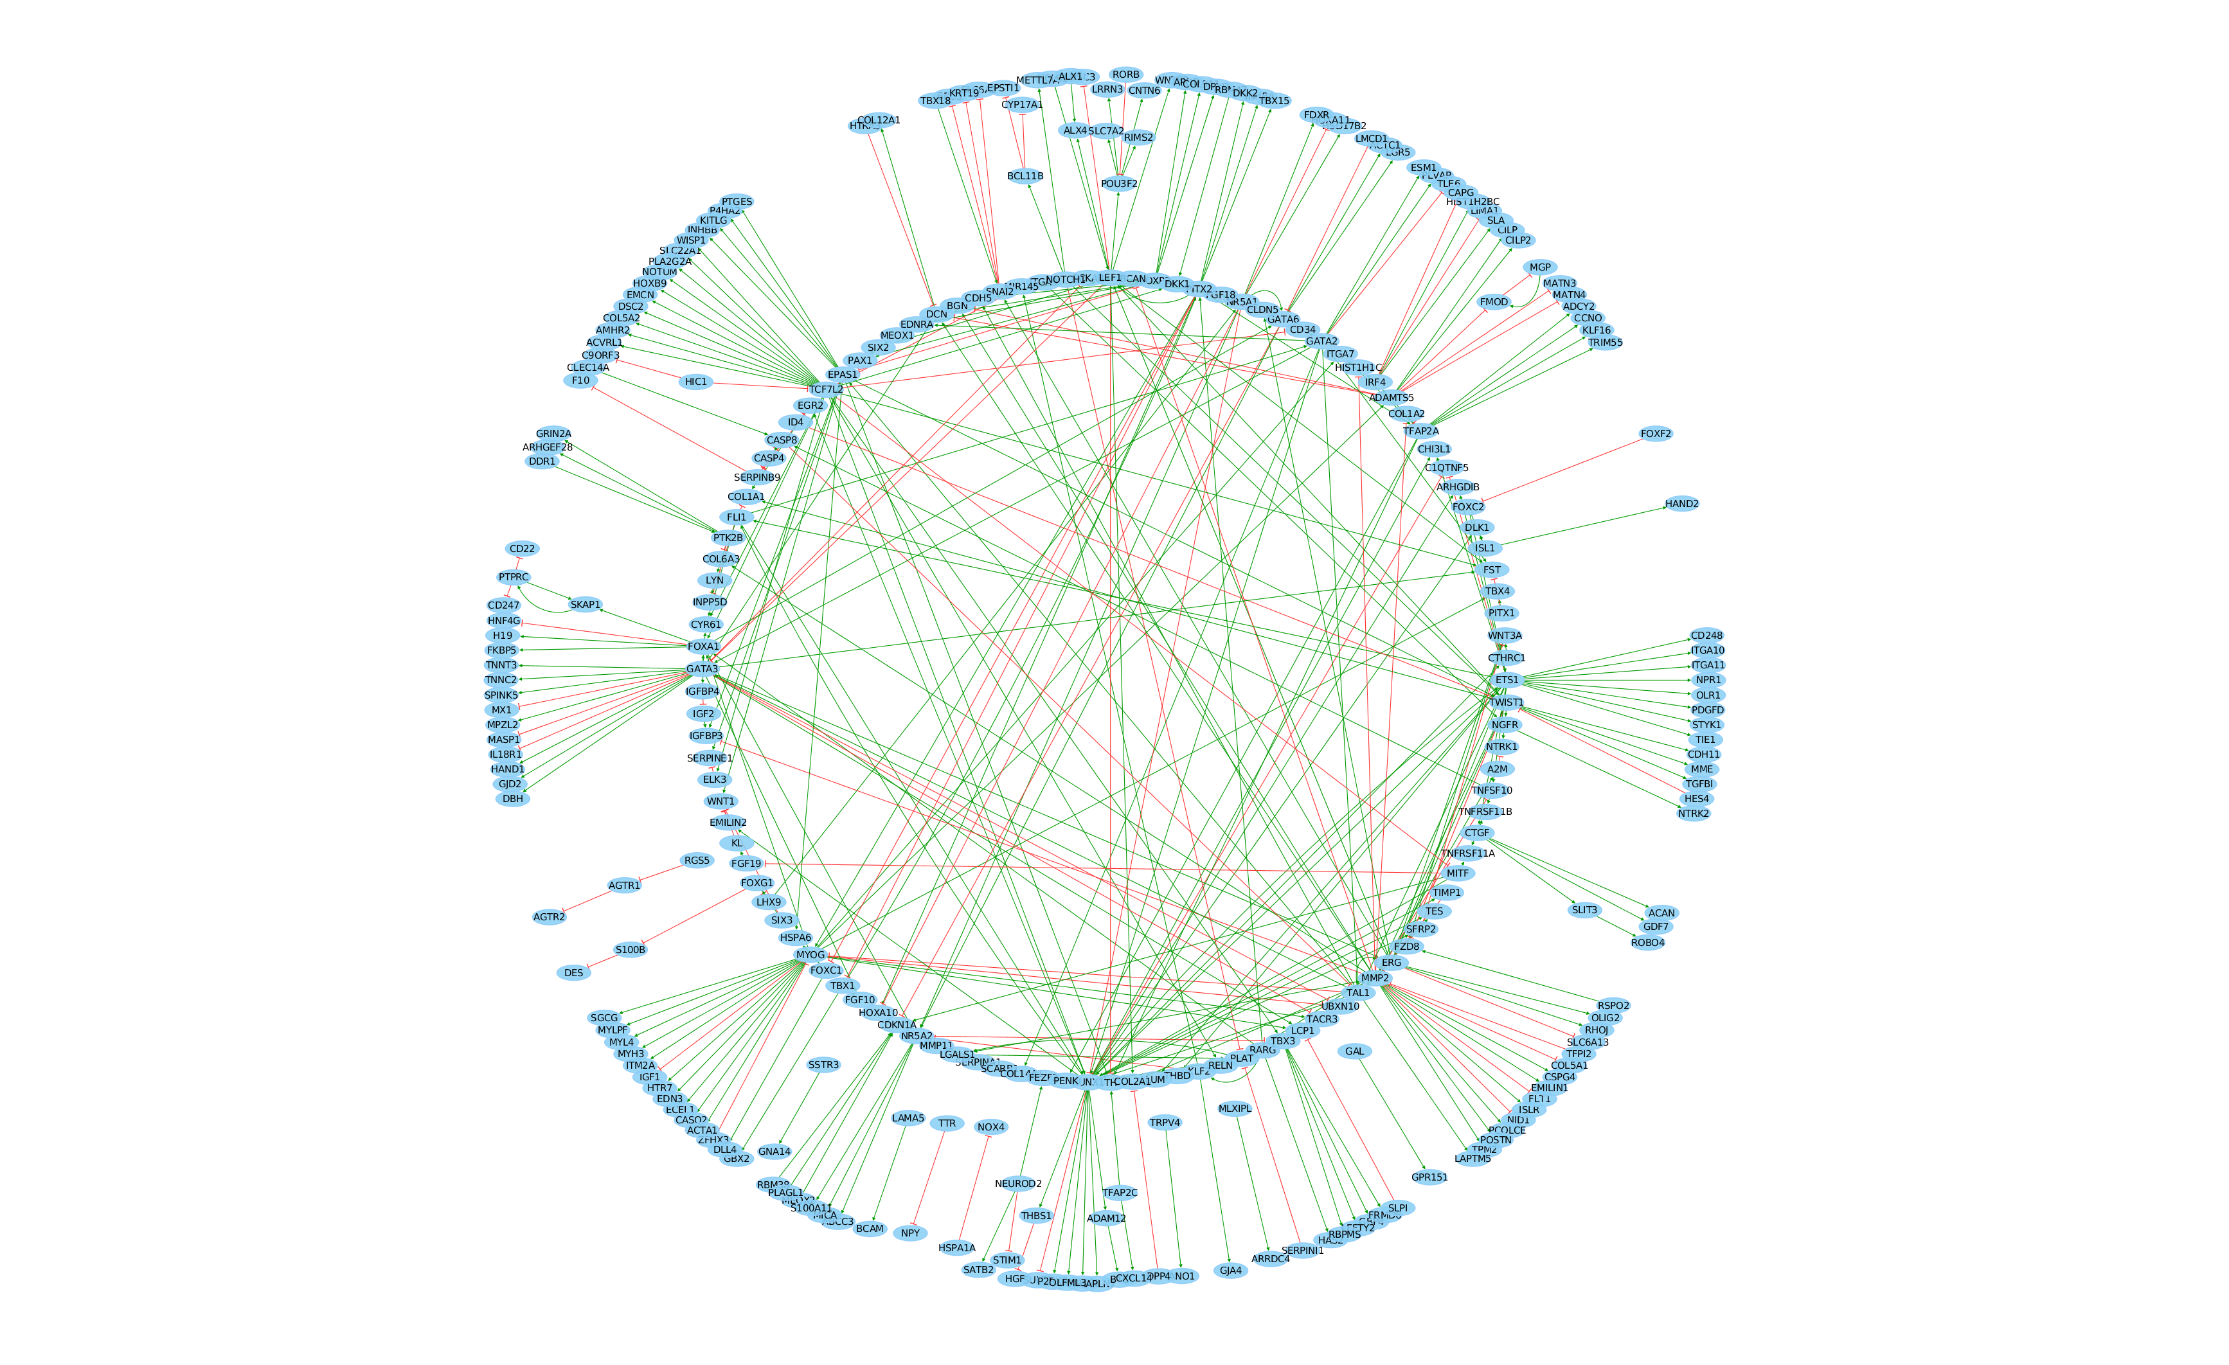

A

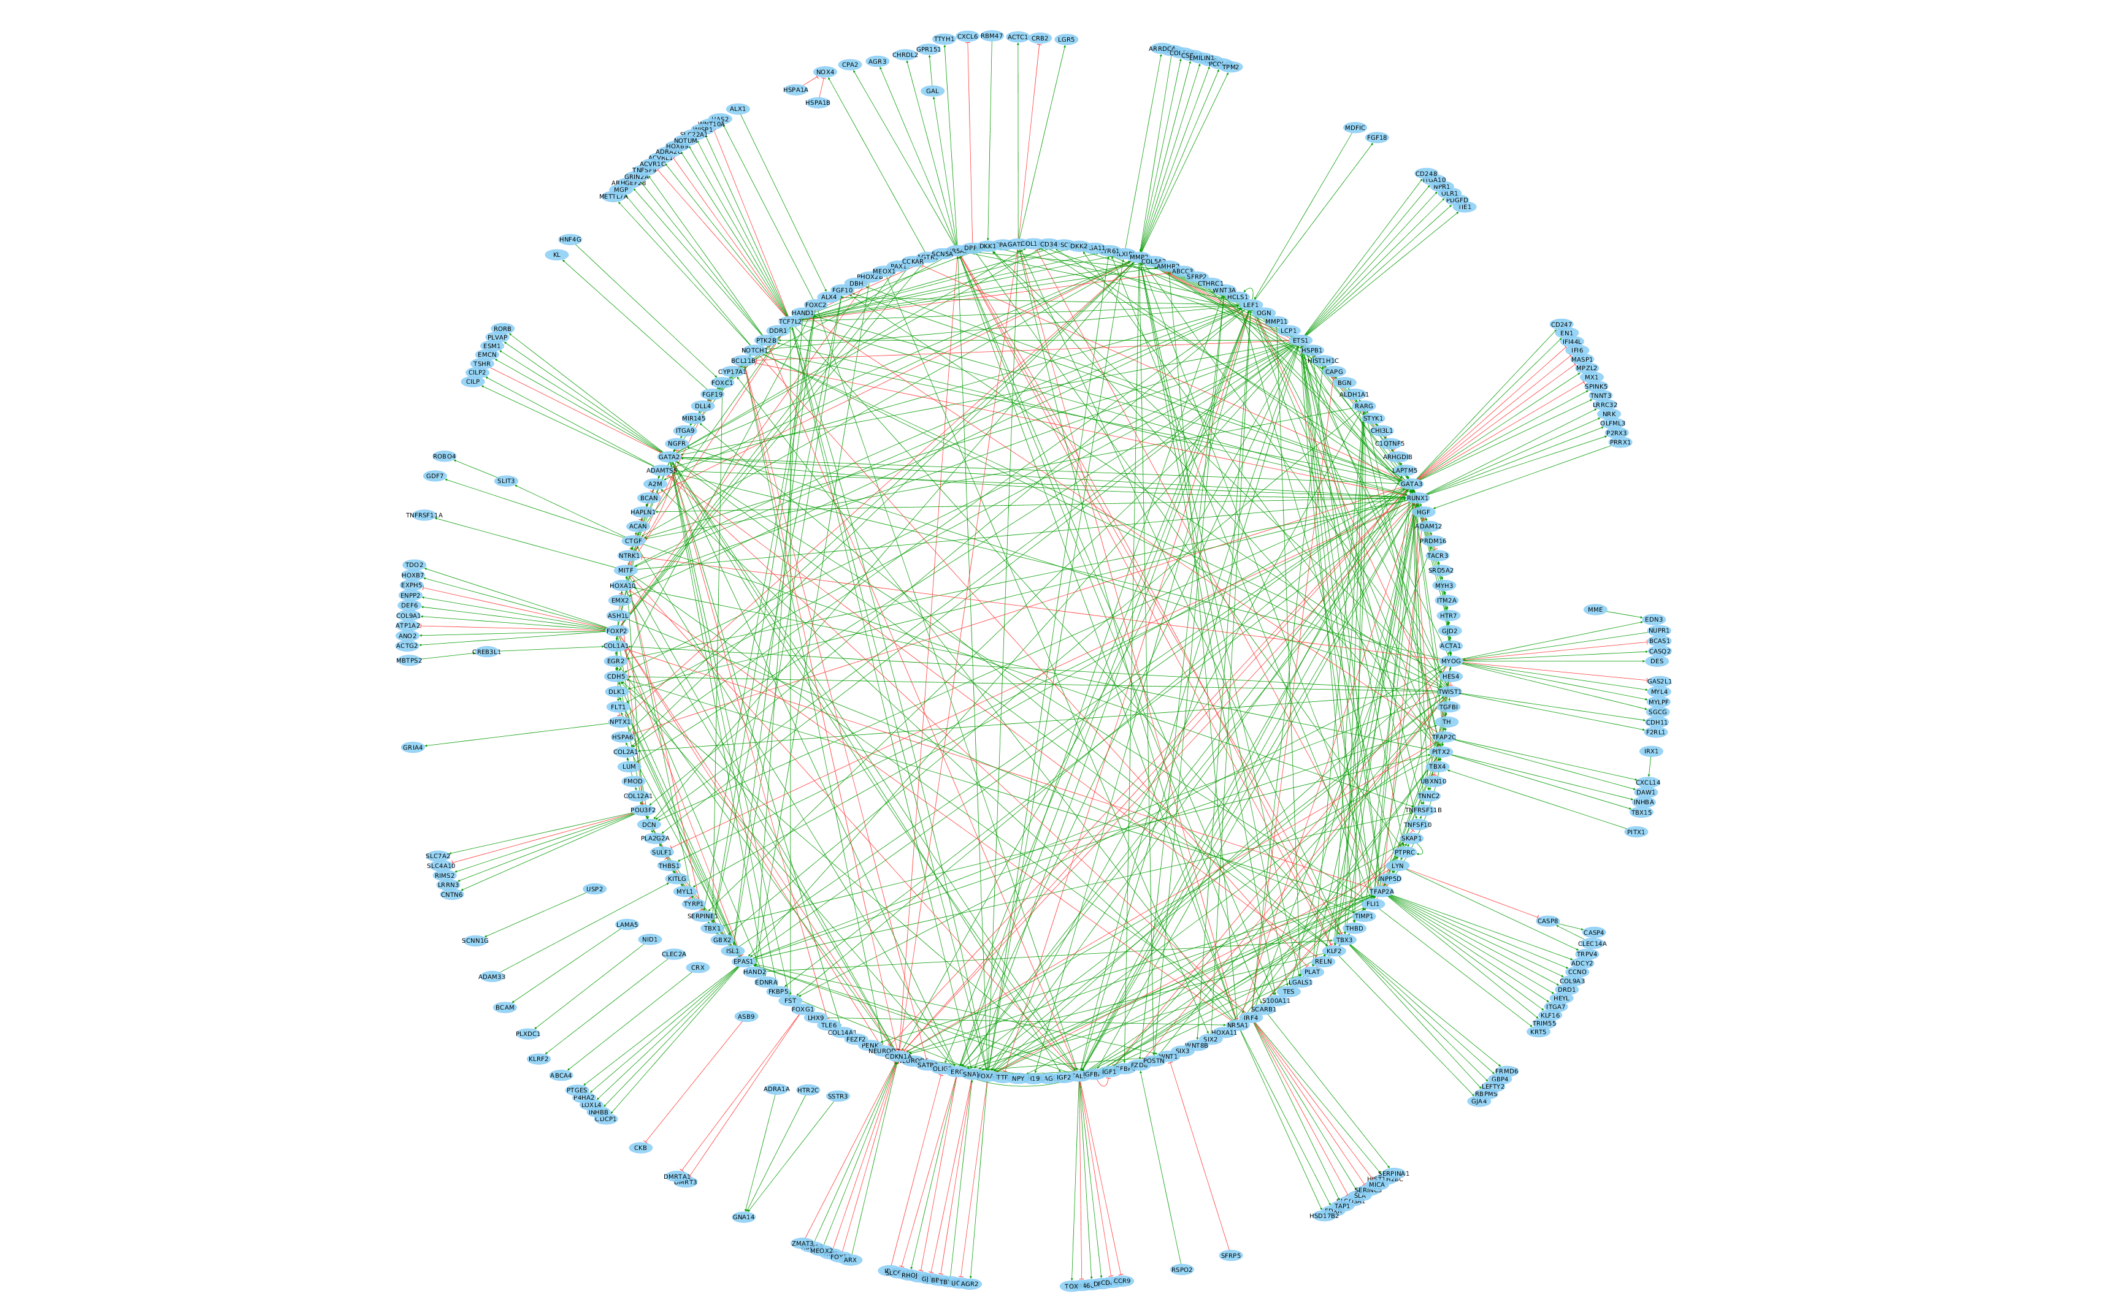

B

**Figure S2**: A) Gene regulatory network representing the healthy phenotype (on the top) contains 298 nodes (TFs and genes) and 399 interactions. Green arrowhead lines in the network represent activations, while the red ones represent inhibitions. B) The healthy phenotype network contains 292 activating and 107 inhibitory interactions. Disease network (on the bottom) contains 353 nodes and 641 interactions with 520 and 121 activating and inhibitory interactions, respectively.