# Supplementary Western blotting data

Parkinson's disease mutant Miro1 causes mitochondrial dysfunction and dopaminergic neuron loss

Axel Chemla1, Giuseppe Arena1, Ginevra Sacripanti1, Kyriaki Barmpa1, Alise Zagare1, Pierre Garcia1,2, Vyron Gorgogietas1, Paul Antony1, Jochen Ohnmacht3, Alexandre Baron1, Jaqueline Jung4, Frida Lind-Holm Mogensen3,5, Alessandro Michelucci3, Anne-Marie Marzesco1,§, Manuel Buttini1,2, Thorsten Schmidt4, Anne Grünewald1,6, Jens C. Schwamborn1,*, Rejko Krüger1,3,7,*, Cláudia Saraiva1,*

**Affiliations:**

1Luxembourg Centre for Systems Biomedicine (LCSB), University of Luxembourg, L-4362 Esch-sur-Alzette, Luxembourg

2Luxembourg Center of Neuropathology (LCNP), Laboratoire National de Santé, L-3555, Dudelange, Luxembourg

3 Luxembourg Institute of Health (LIH), L-1445 Luxembourg, Luxembourg

4Institute of Medical Genetics and Applied Genomics, University of Tübingen, 72076 Tübingen, Germany

5Faculty of Science, Technology and Medicine, University of Luxembourg, L-4365 Esch-sur-Alzette, Luxembourg

6Institute of Neurogenetics, University of Lübeck, 160 Lübeck, Germany

7Centre Hospitalier de Luxembourg, L-1210, Luxembourg, Luxembourg

§ Current address: University Medical Center Hamburg-Eppendorf, Center for Molecular Neurobiology Hamburg, 20246 Hamburg, Germany

*  Senior authors

Correspondence to: jens.schwamborn@uni.lu (JCS), rejko.krueger@lih.lu (RK) and claudia.saraiva@uni.lu (CS)

# Supplementary Western blotting data

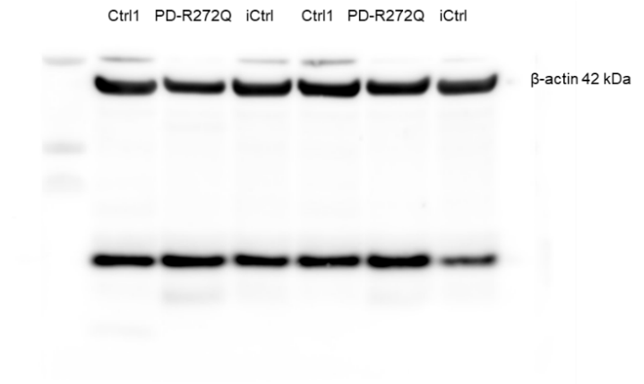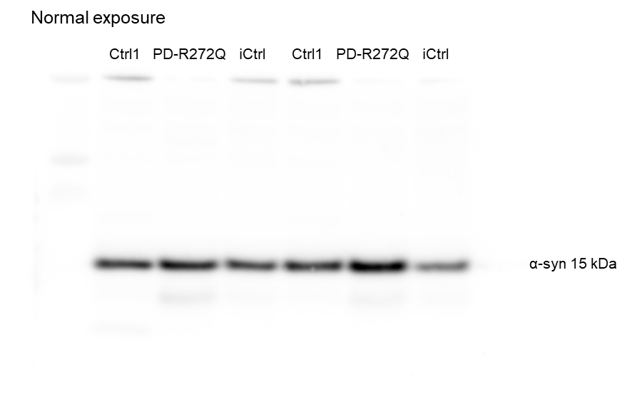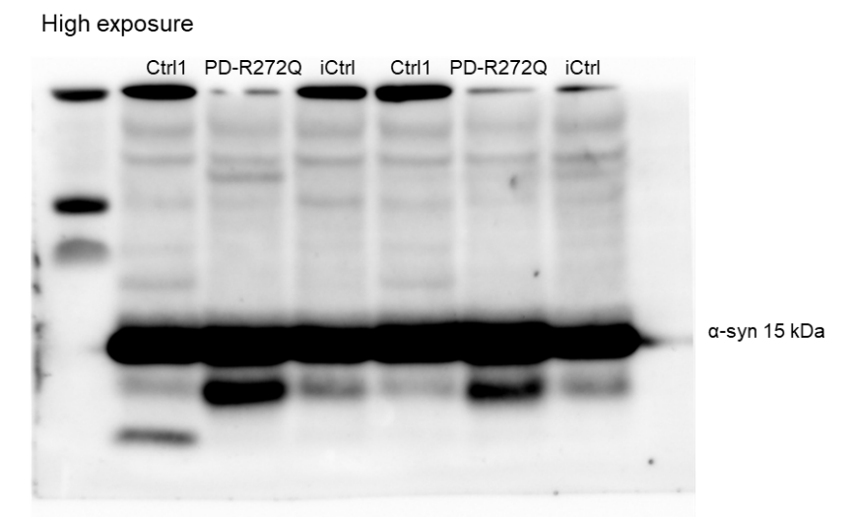

**WB1.** Original full length membrane referent to the data displayed at Main Figure 4B. Left: α-synuclein normal (top) and high (bottom) exposures. Right: full membrane showing β-actin.

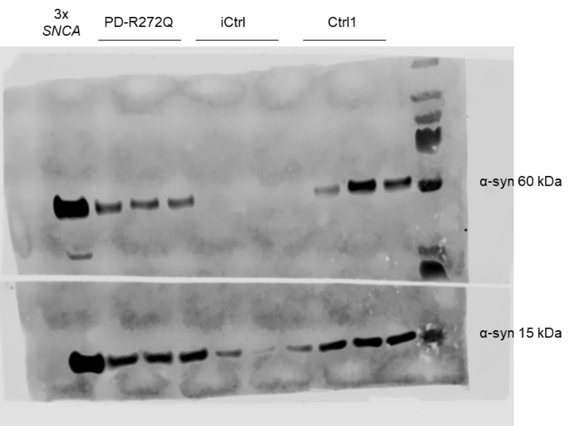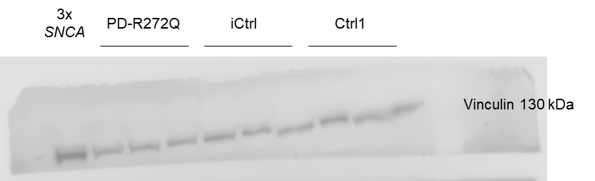

**WB2.** Original membrane shown at Main Figure 4F, blotted for α-synuclein (left) and Vinculin (right).

**WB3.** Original membrane shown at Main Figure 5A, blotted for tyrosine hydroxylase (TH, left) and β-actin (right).

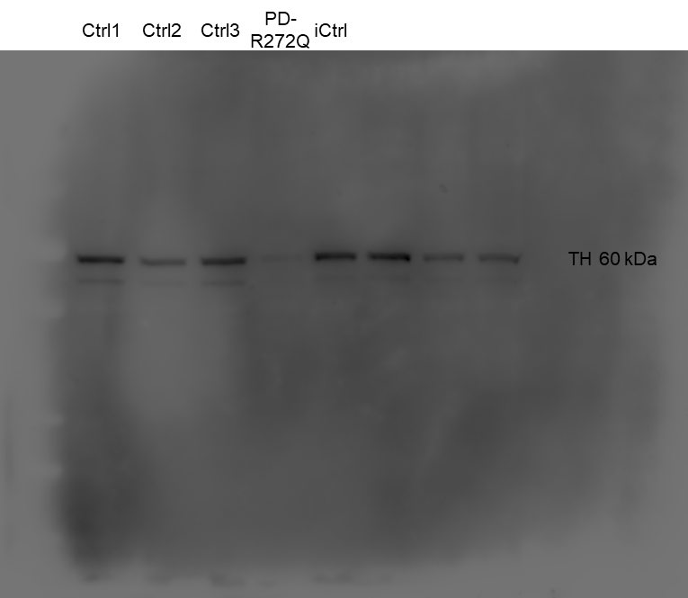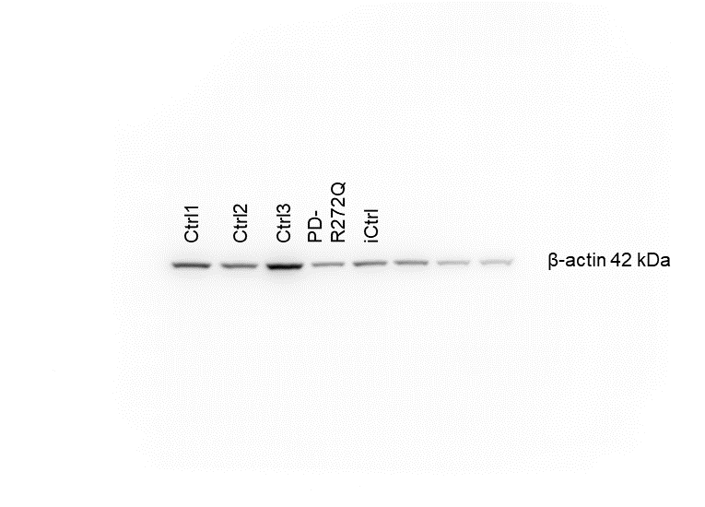

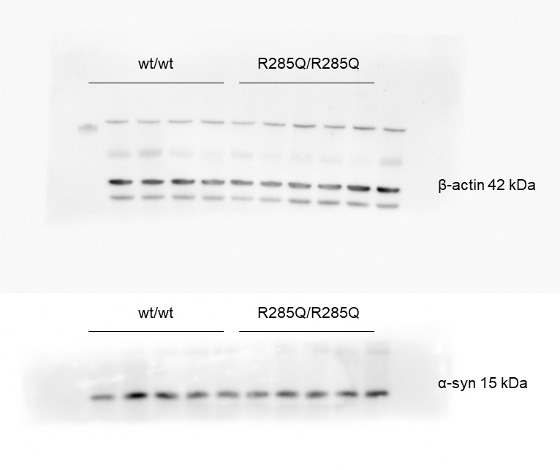

**WB4.** Original membrane shown at Main Figure 6E, blotted for β-actin (top) and α-synuclein (α-syn, bottom).

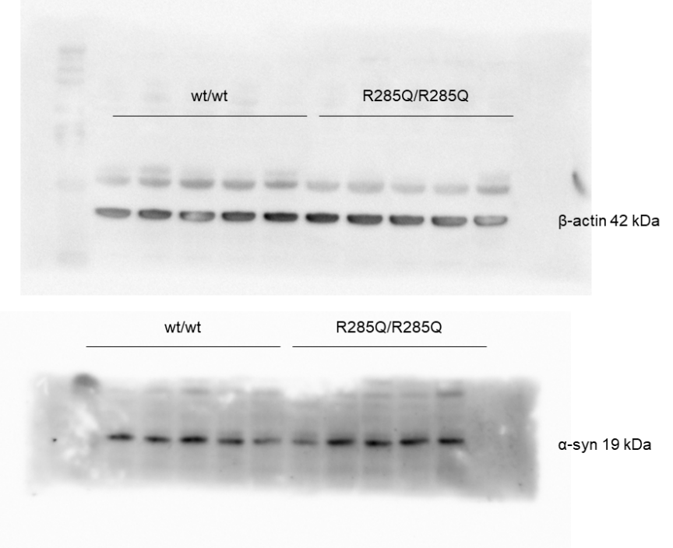**WB5.** Original membrane shown at Main Figure 6F, blotted for β-actin (top) and phosphorylated S129 α-synuclein (α-syn, bottom).

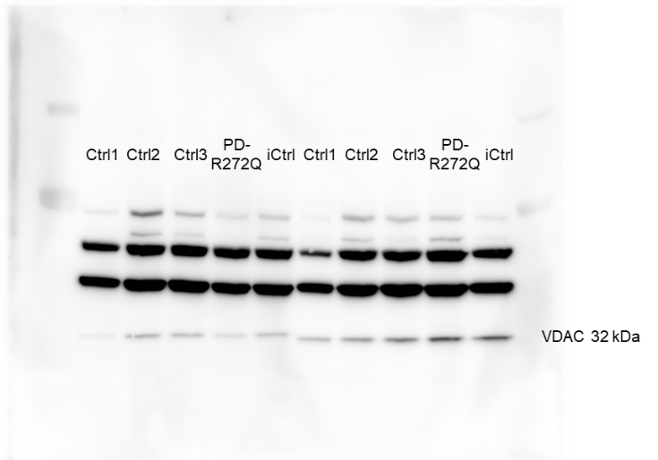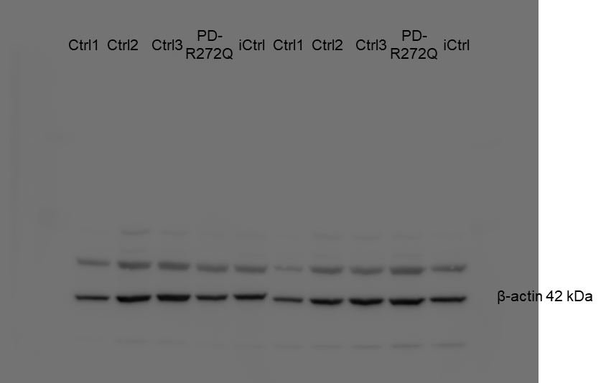

**WB6.** Original membrane shown at Supplementary Figure 4B, blotted for VDAC (left) and β-actin (right).

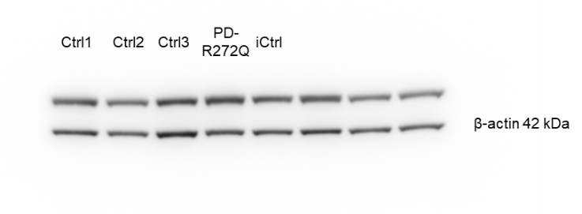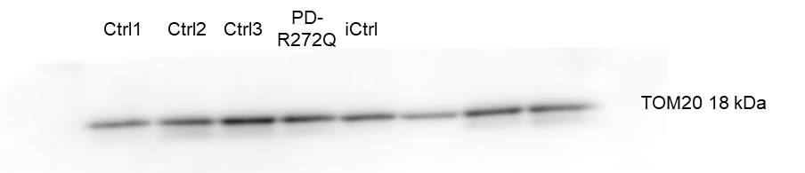

**WB7.** Original membrane shown at Supplementary Figure 4C, blotted for TOM20 (right) and β-actin (left).

**WB8.** Original membrane shown at Supplementary Figure 4D, blotted for FTL (left) and β-actin (right).

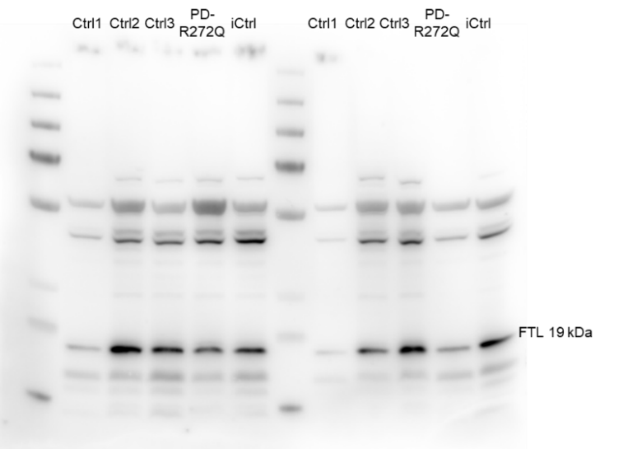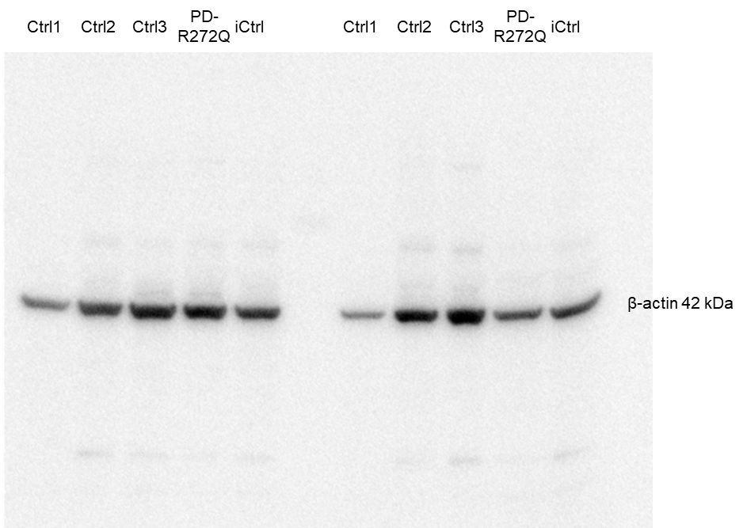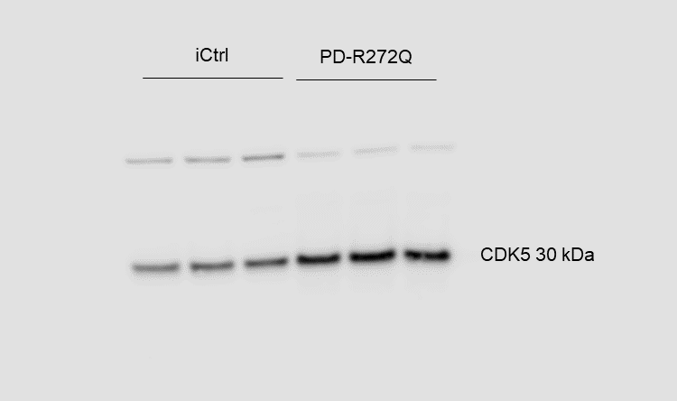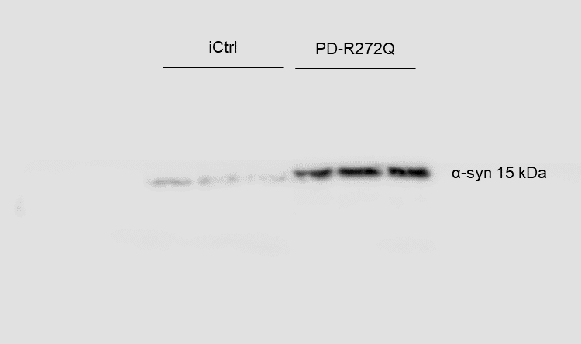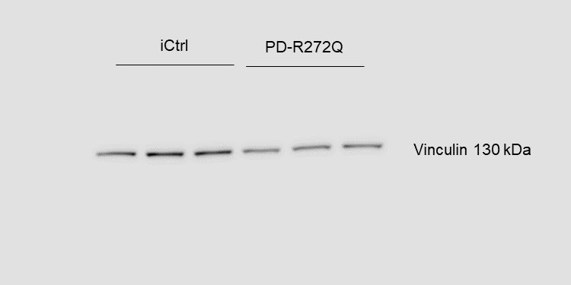

**WB9.** Original membrane shown at Supplementary Figure 6E, blotted for CDK5 (top left), α-synuclein (top right) and vinculin (bottom).

**WB10.** Original membrane shown at Supplementary Figure 9C, blotted for TOM20 (left) and β-actin (right).

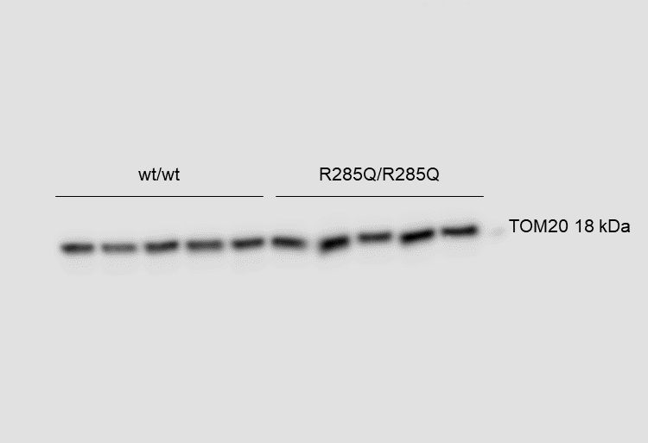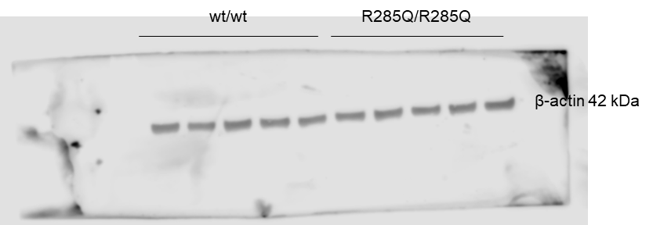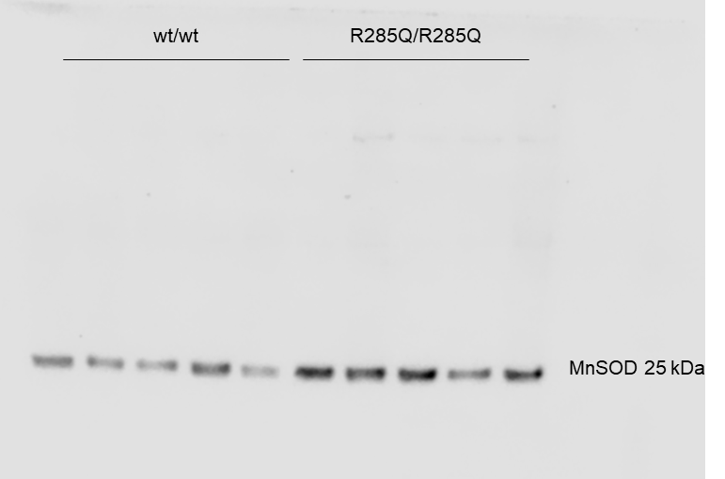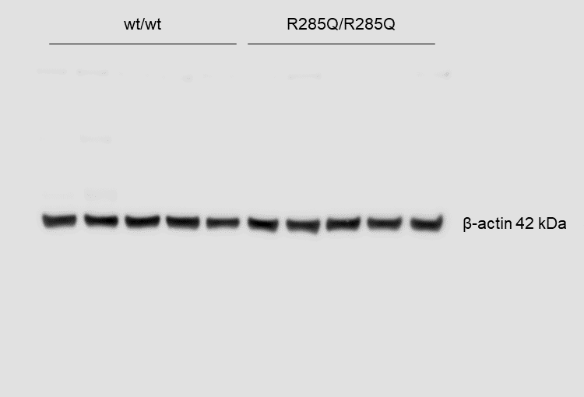

**WB11.** Original membrane shown at Supplementary Figure 9D, blotted for MnSOD (left) and β-actin (right).

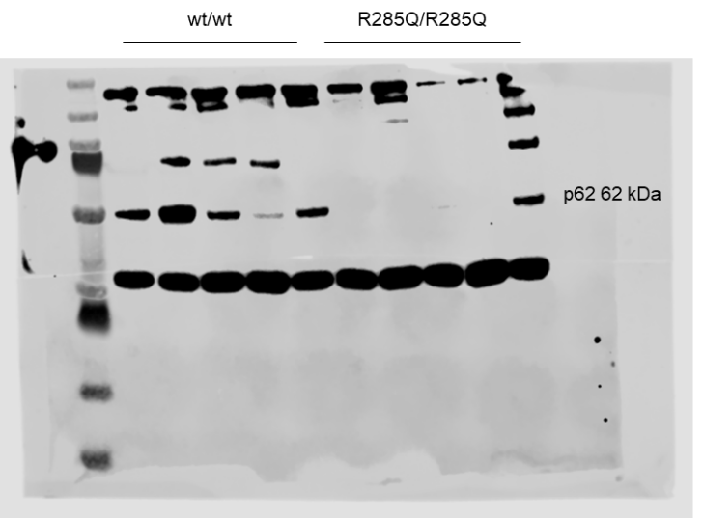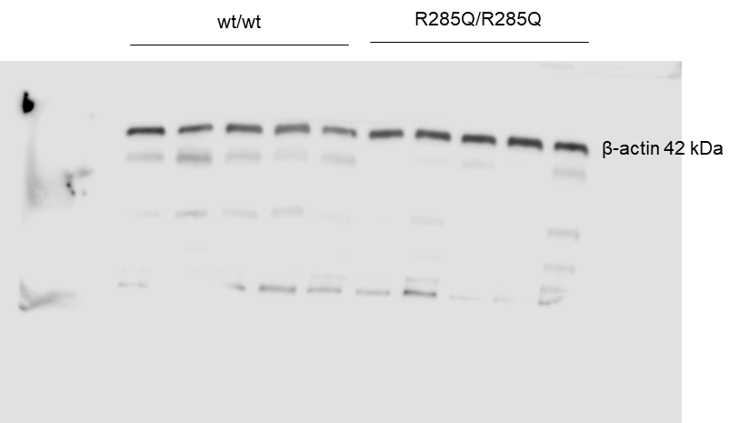

**WB12.** Original membrane shown at Supplementary Figure 9E, blotted for p62 (left) and β-actin (right).

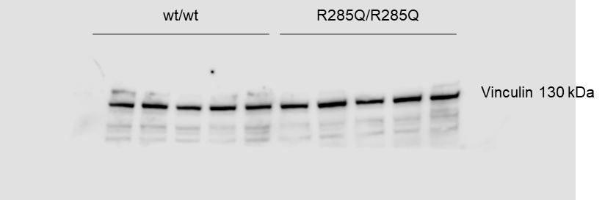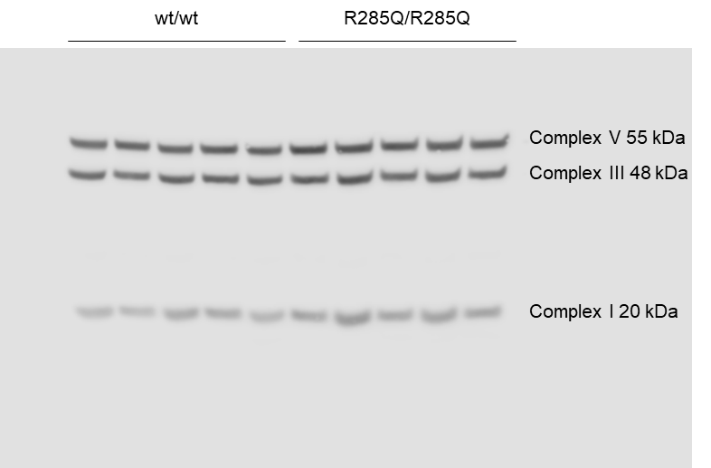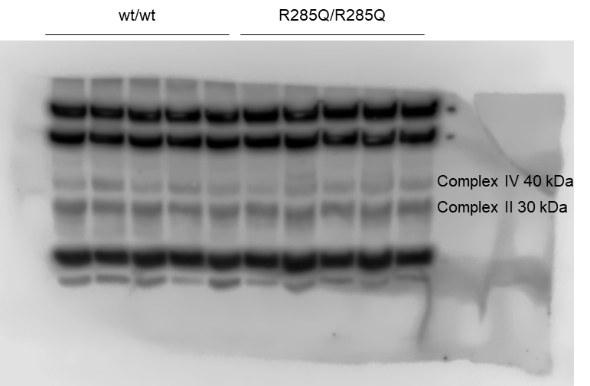

**WB13.** Original membrane shown at Supplementary Figure 9F, blotted for Vinculin (top) and mitochondrial complex V, III, and I (bottom left) as well as mitochondrial complex IV and II (bottom right).